**Task 10:**

**Aim:** Identify Web elements using Id, Name and XPath using Selenium IDE.

**Procedure:**

**Steps:**

1. Search firebug for chrome 🡪 click firebug lite for chrome.

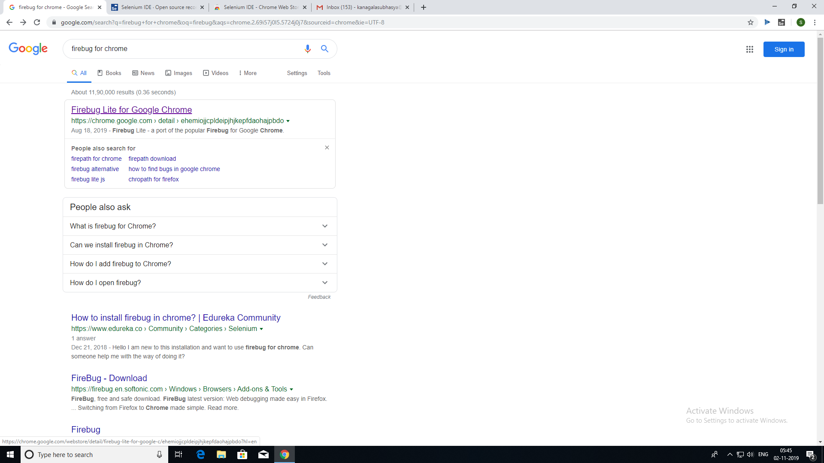

1. Click add to chrome.

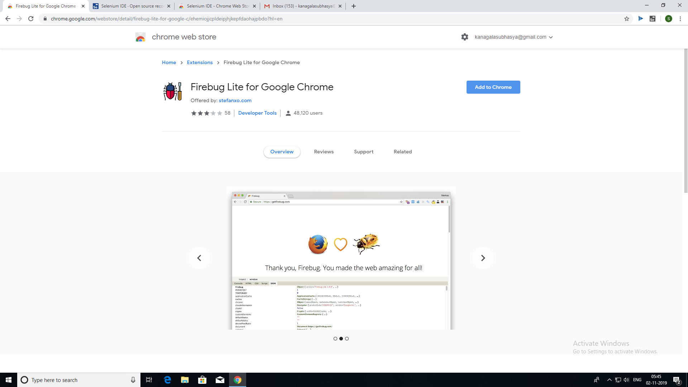

1. Click add extension.

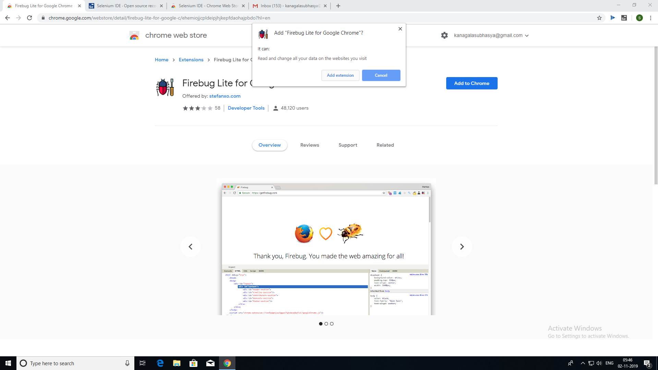

1. Open facebook home page.

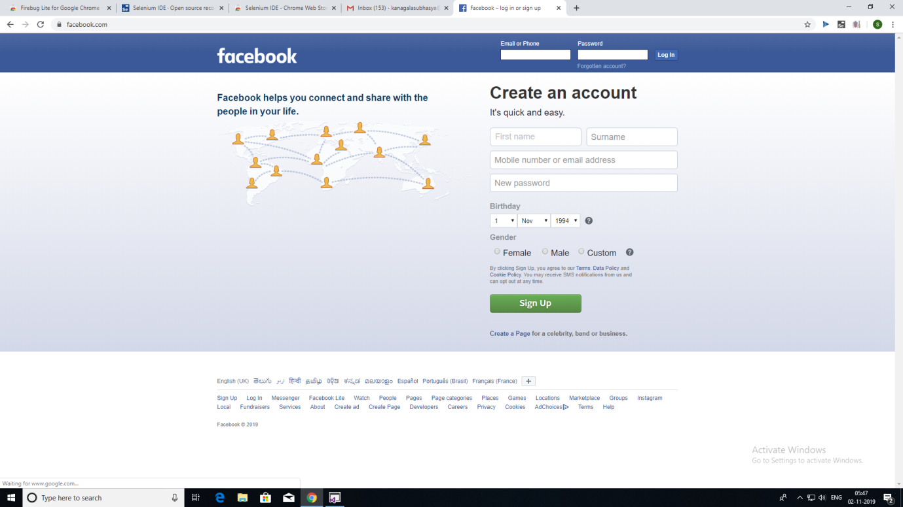

1. Click on firebug.

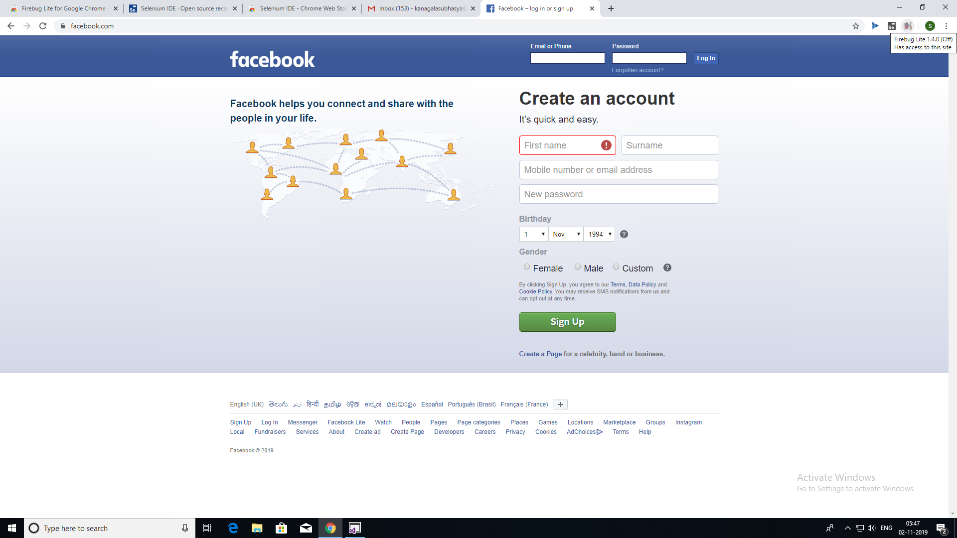

1. Click ok.

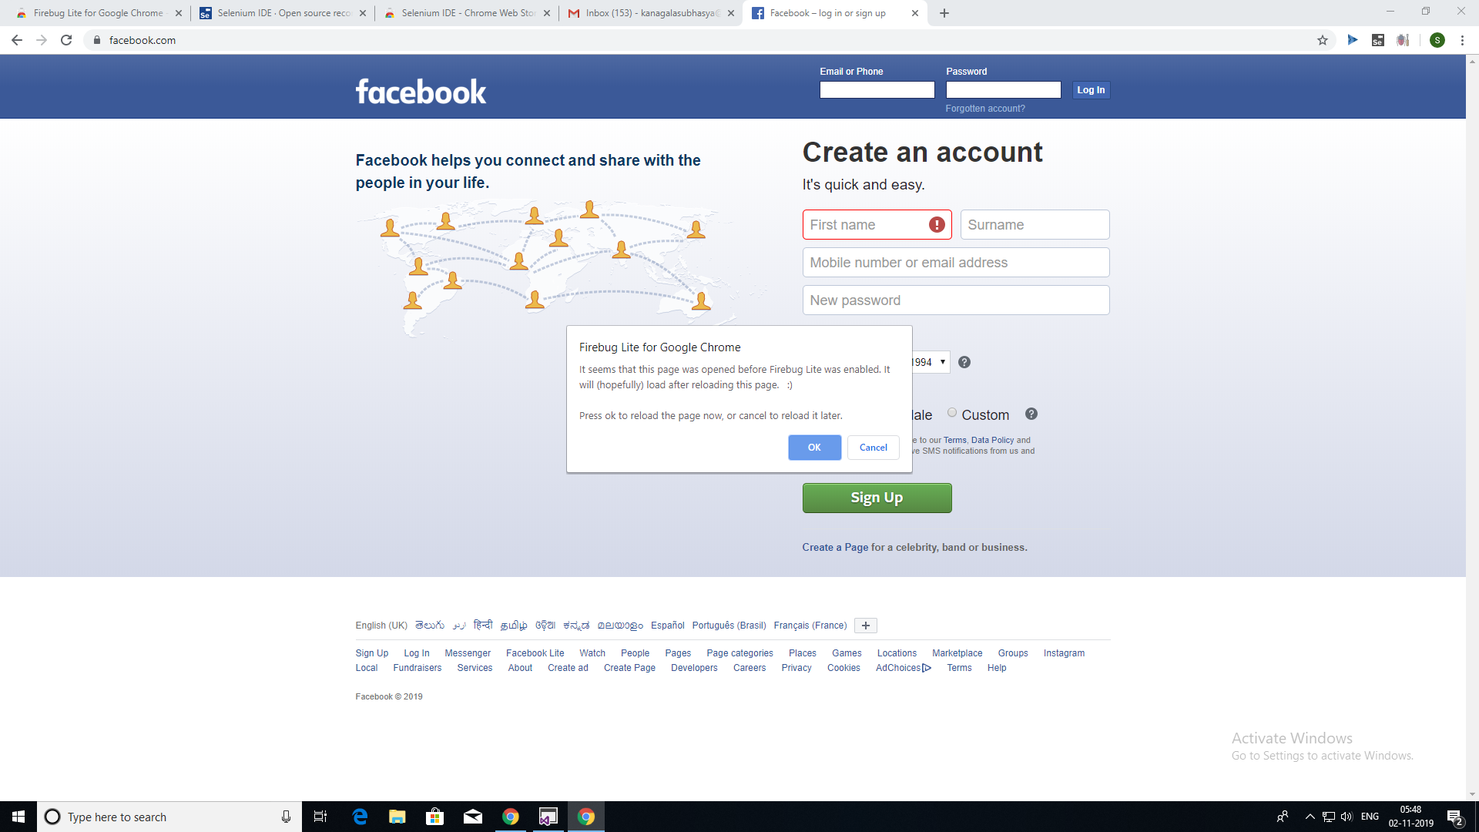

1. Click on fire bug again. It will open console below.



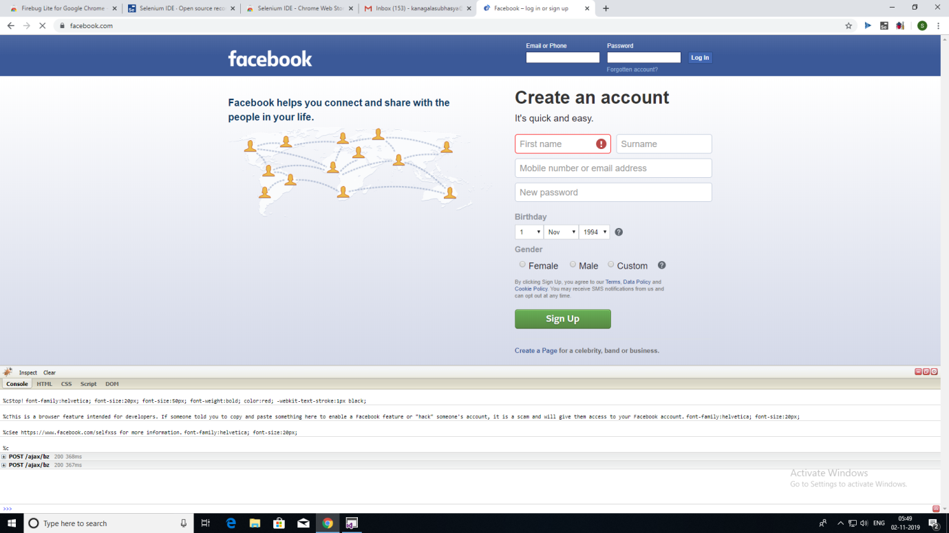

1. Click on inspect button.

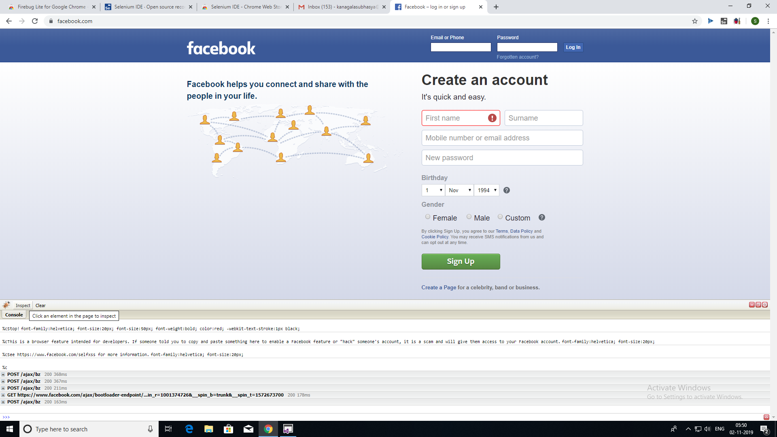

Hover on the required element present on facebook login page, then we will get Class, Id corresponding to that element.

**Identifying Web elements using Id using Selenium IDE:**

1. Hover on Email or Phone text box field to get its details and copy its ID field from the code.

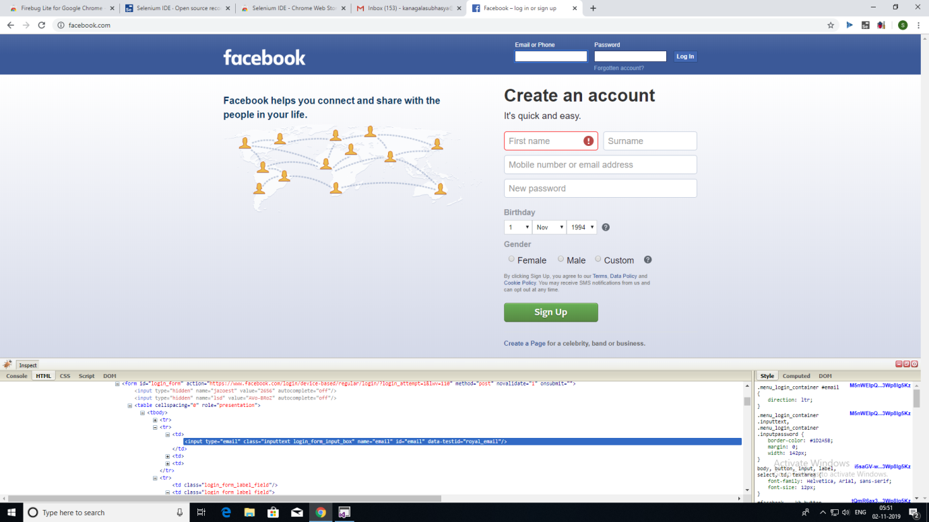

1. Click on selenium and click record a new test in a new project.

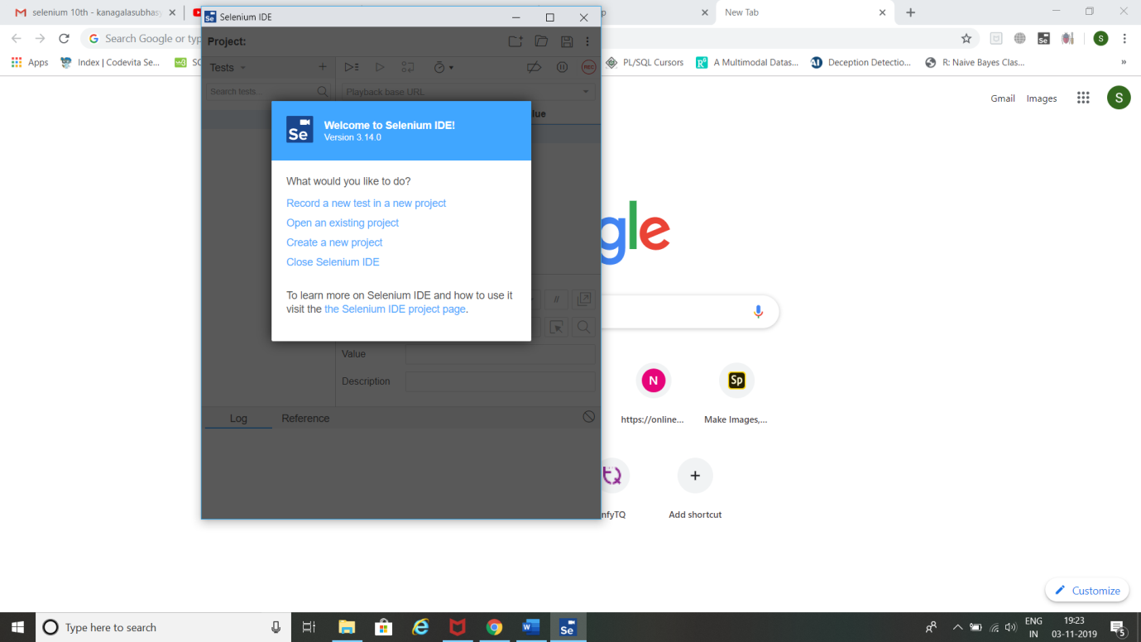

1. Name your project 🡪 Give Facebook home page URL and click Start Recording.

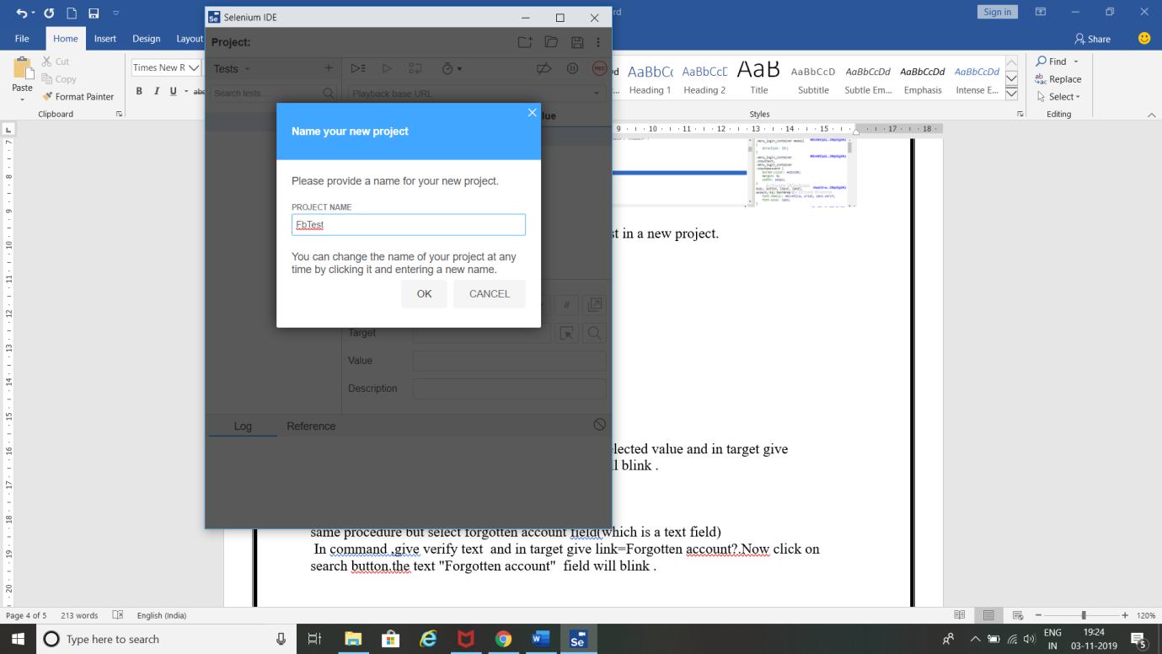

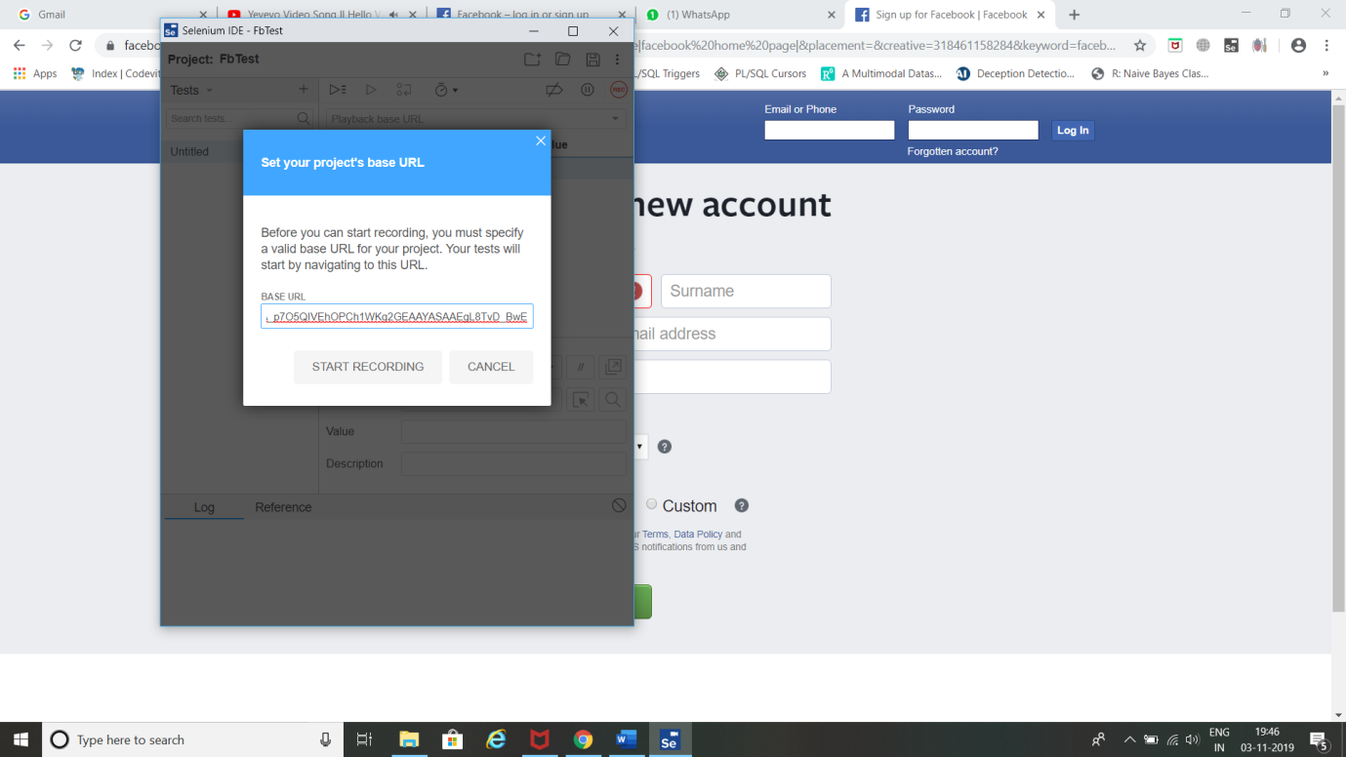

1. Selenium opens the given url and starts recording the action you will be performing in that page.

(Note: Don’t close that facebook page opened by selenium IDE)

Now minimize Facebook page.

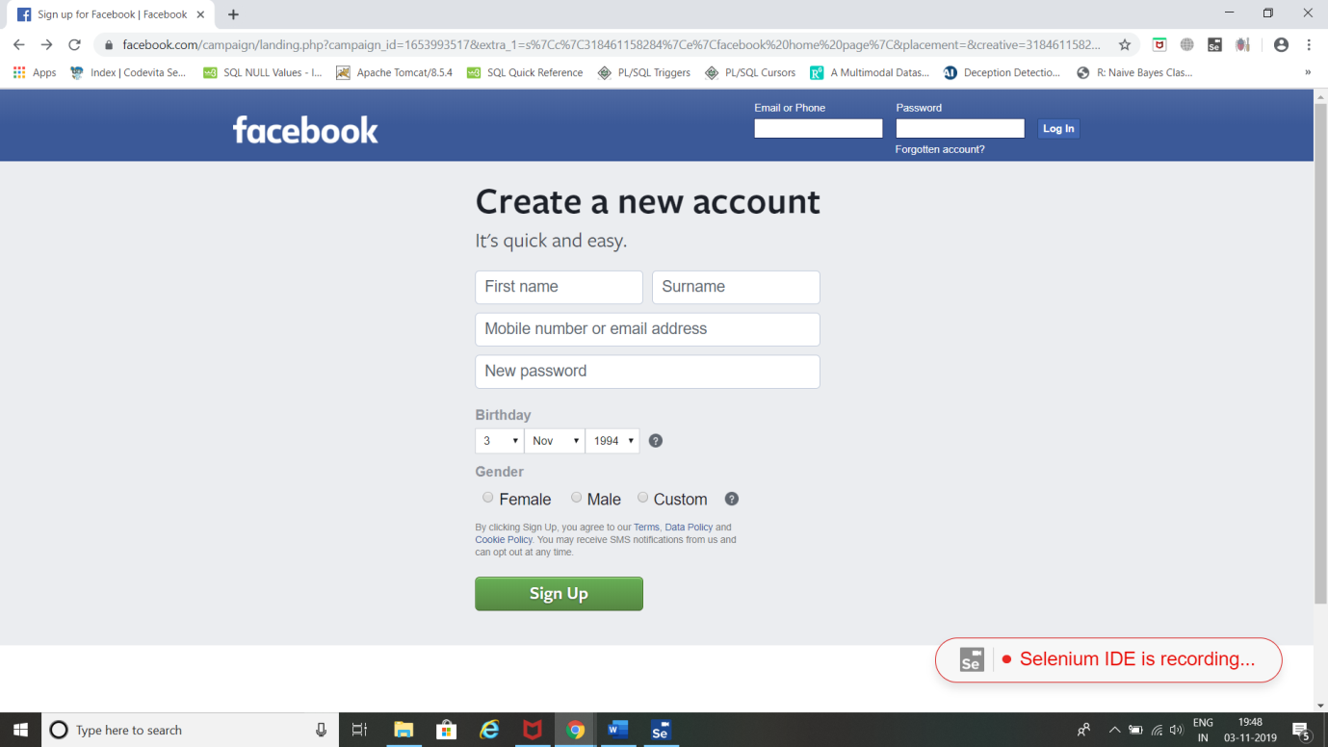

1. Click stop recording 🡪 Give Test Name and click OK.

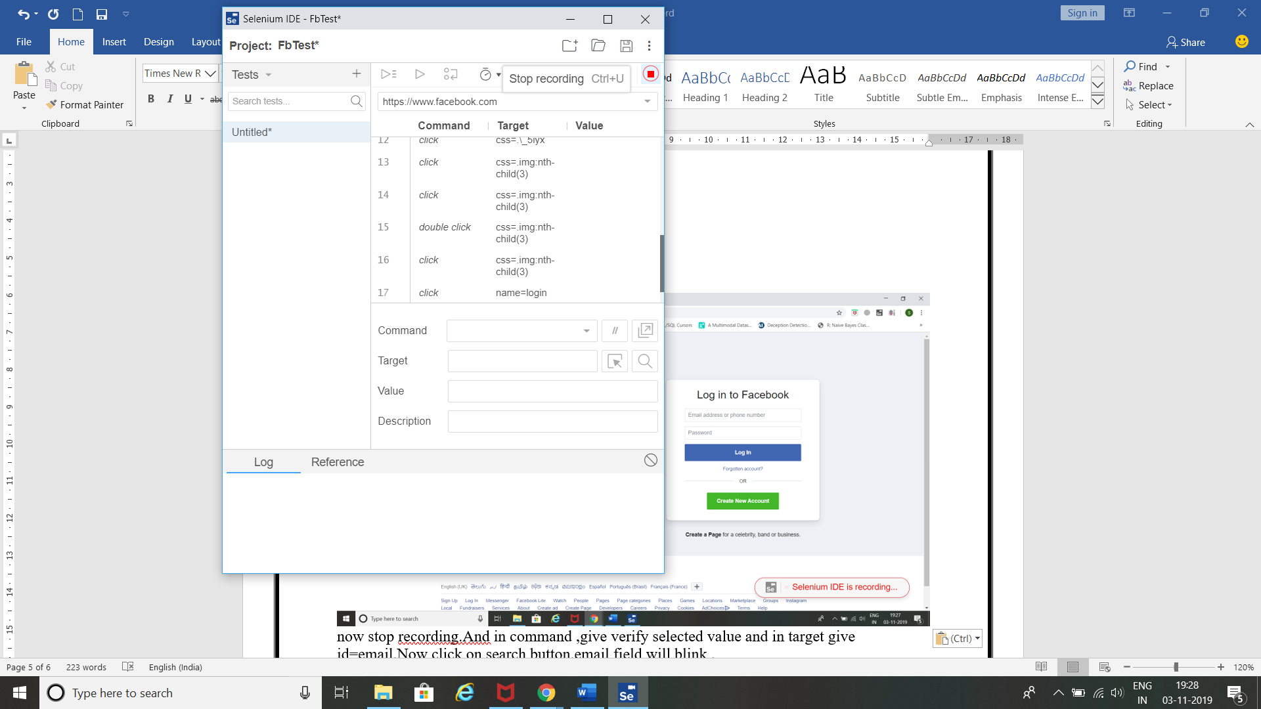

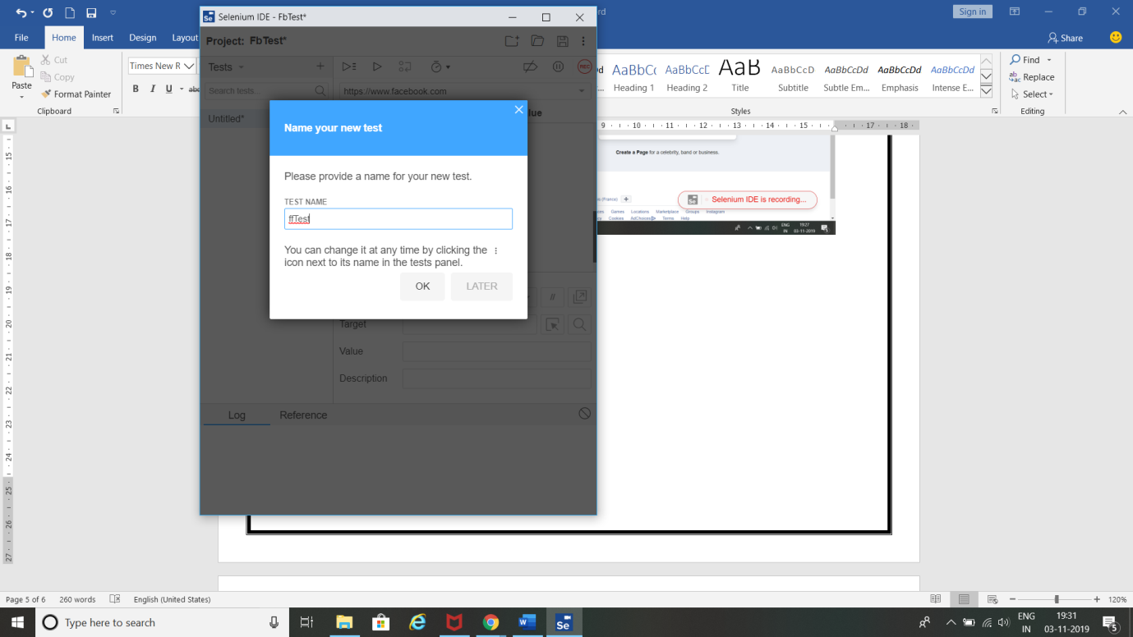

1. In command field, give **verify selected value** and in target give **id=email**.

(Note: email is the ID value for email field present in facebook login page which was copied before).

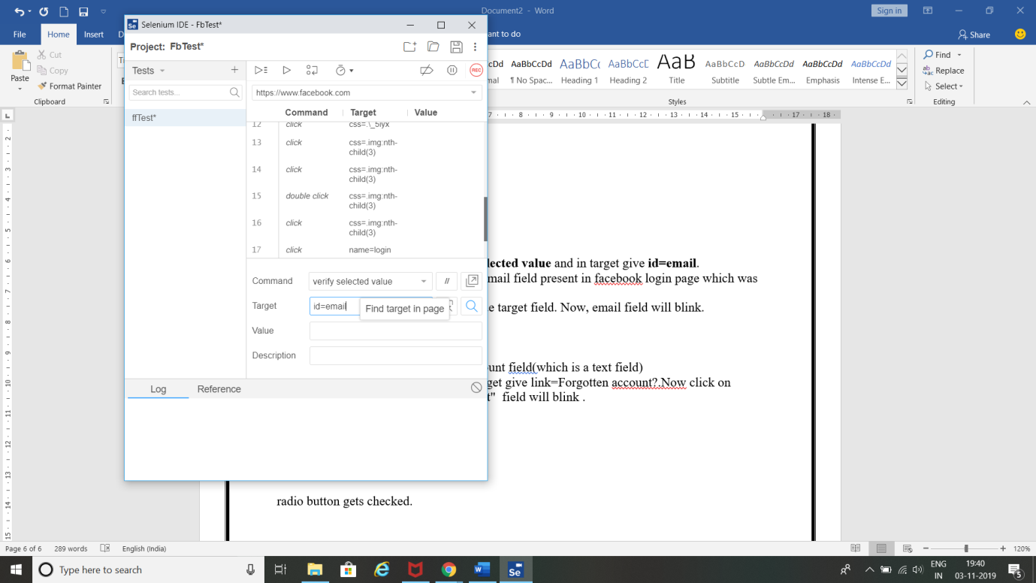

1. Now click on search button beside target field. Now, email field will blink.

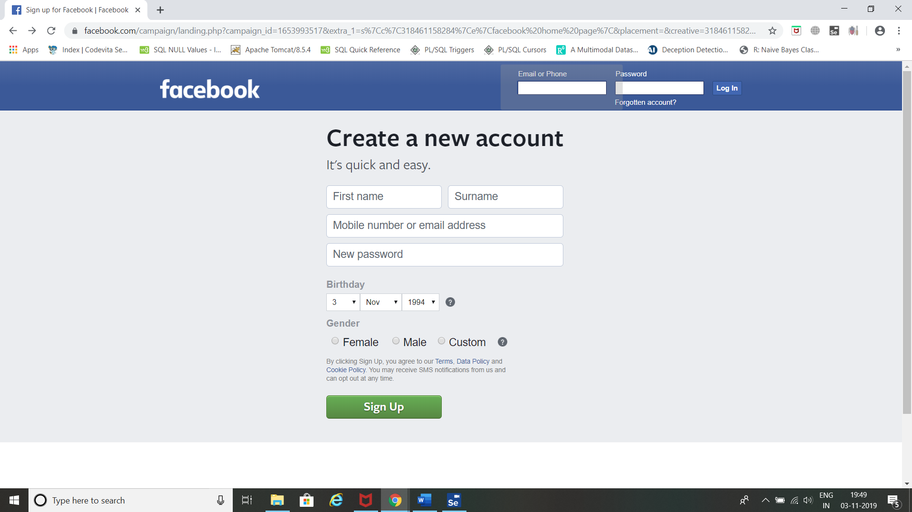

**Identifying Web elements using Name using Selenium IDE:**

1. Now inspect and copy **name** field value for Email or Phone field.

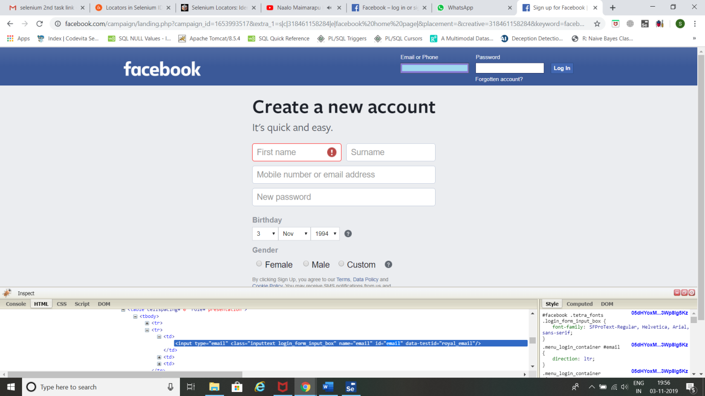

1. In command field, give **verify selected value** and in target give **name=email.**
2. (Note: **email** is the name value for email field present in facebook home page which was copied before).

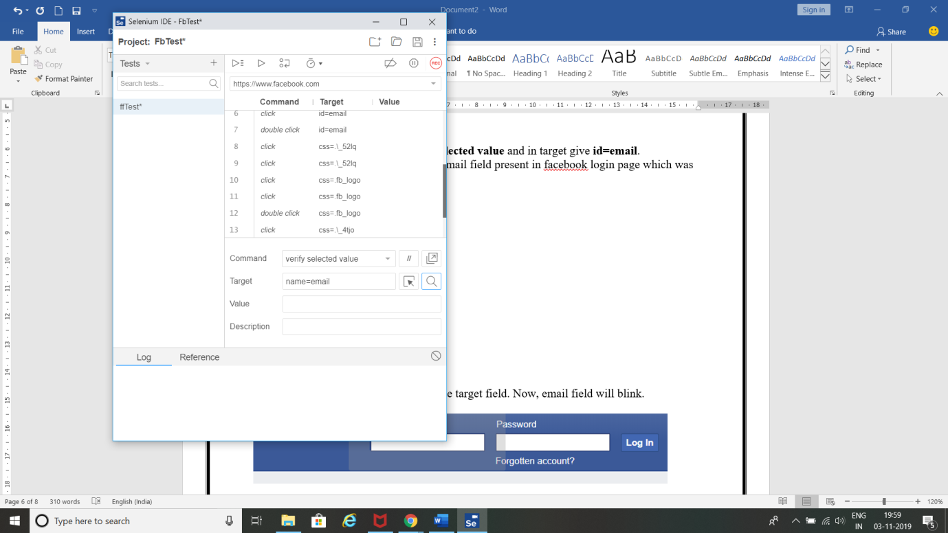

1. Now click on search button beside target field. Now, email field will blink.



**Identifying Web elements using XPATH using Selenium IDE:**

1. Open facebook home page in chrome 🡪Right click 🡪 click inspect.

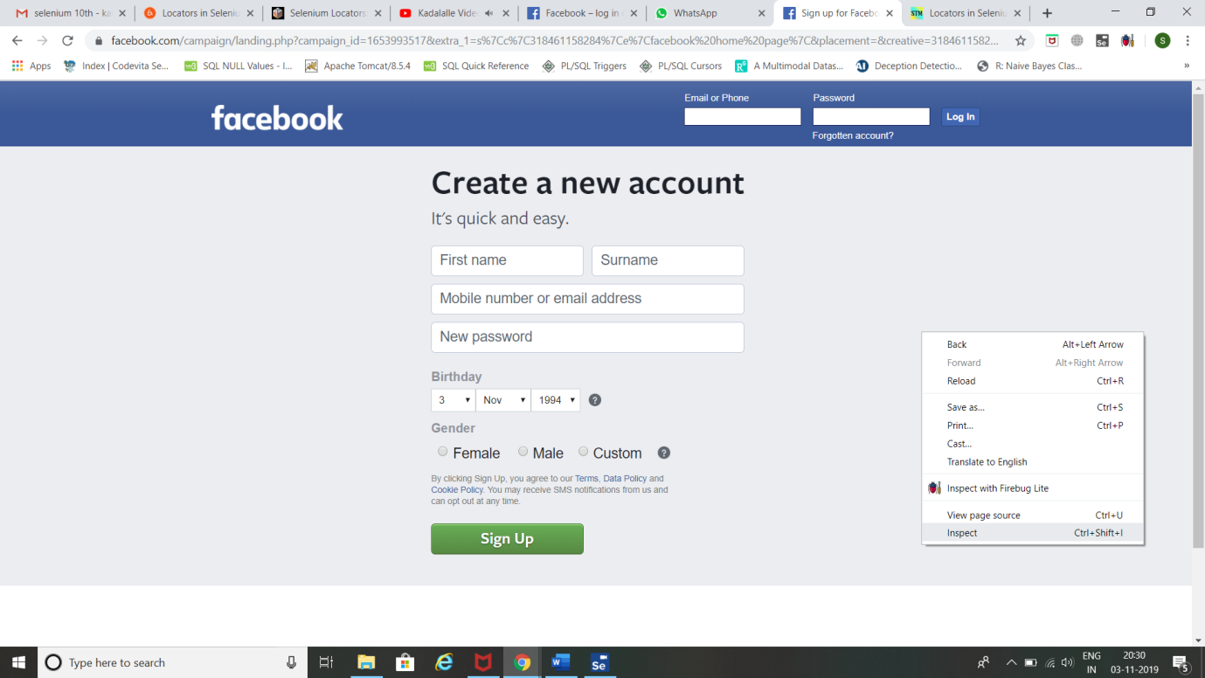

1. Click inspect element 🡪 select **Create a new account** element to inspect.

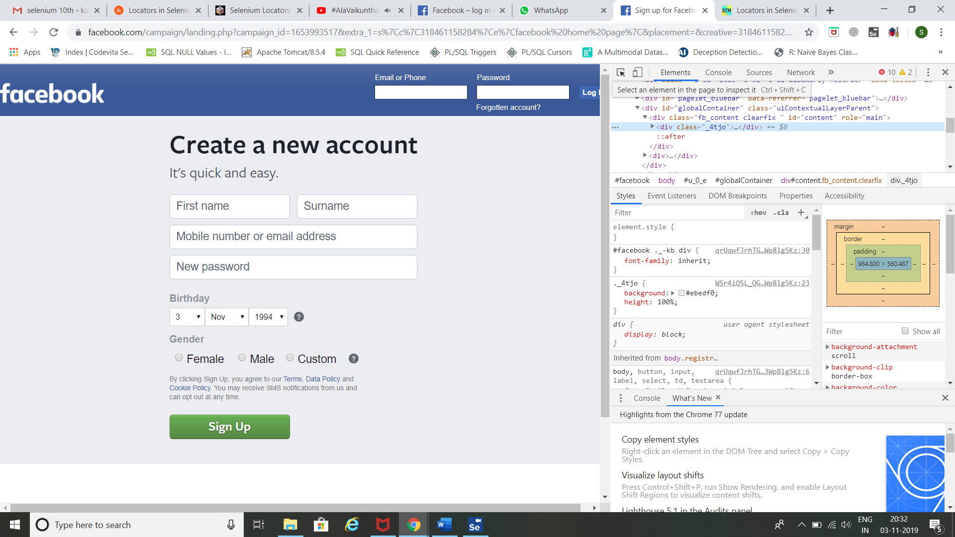

1. Right click on the tag for **Create a new account** 🡪copy 🡪 copy XPath.

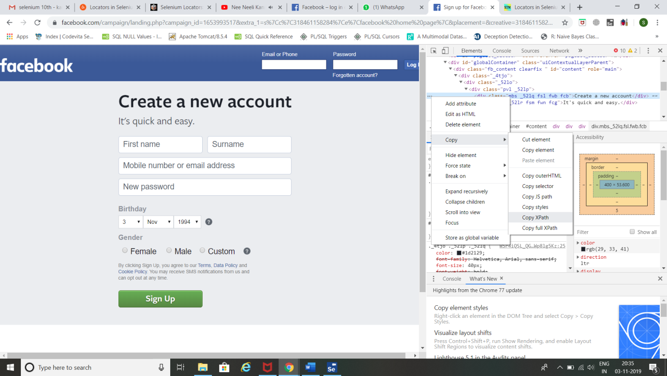

1. Now go to console tab 🡪 give following command.

**$x(‘//*[@id="content"]/div/div/div[1]/div[1]’)**

(Note: //*[@id="content"]/div/div/div[1]/div[1] is the XPath )

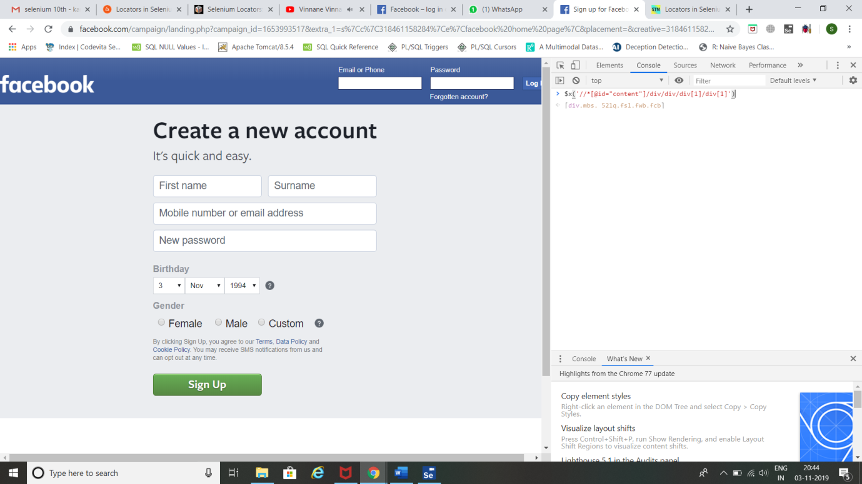

1. Now click the dropdown and hover on the command 🡪 **Create a new account** field gets selected.

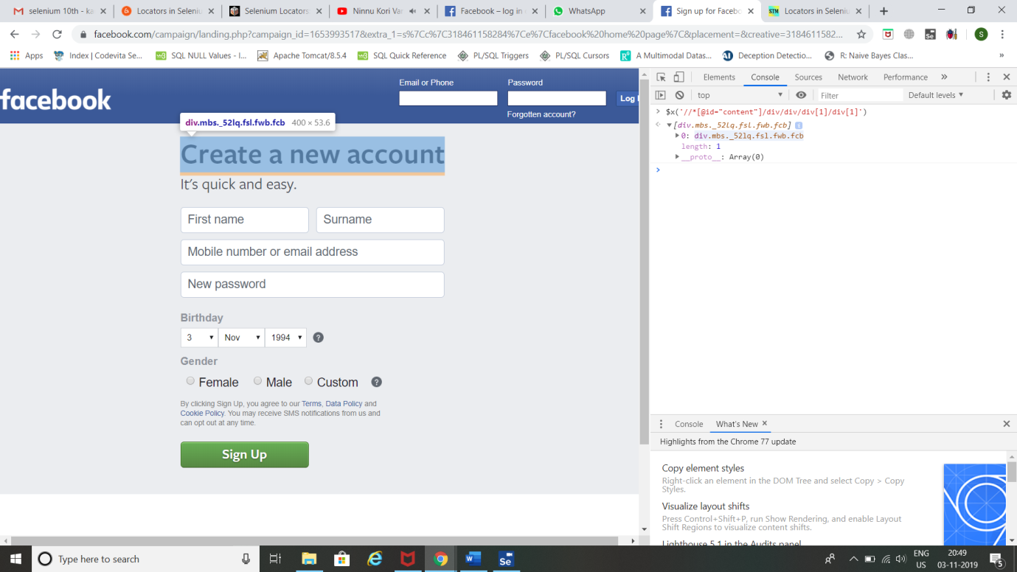

**Result:**

Thus, identifying Web elements using Id, Name and XPath using Selenium IDE has been completed successfully.

**Task 11:**

**Aim:** To use CSS selectors for identifying Web elements for selenium scripts using Selenium IDE

**Procedure:**

**Steps:**

**Using Tag and ID:**

1. Hover on Email or Phone text box field to get its details and copy its ID field from the code.



1. Click on selenium and click record a new test in a new project.



1. Name your project 🡪 Give Facebook home page URL and click Start Recording.





1. Selenium opens the given url and starts recording the action you will be performing in that page.

(Note: Don’t close that facebook page opened by selenium IDE)

Now minimize Facebook page.



1. Click stop recording 🡪 Give Test Name and click OK.





1. In command field, give **verify element present** and in target give **css=input#email**.

(Note: **email** is the ID value for email field present in facebook login page which was copied before. And **input** is tag name).

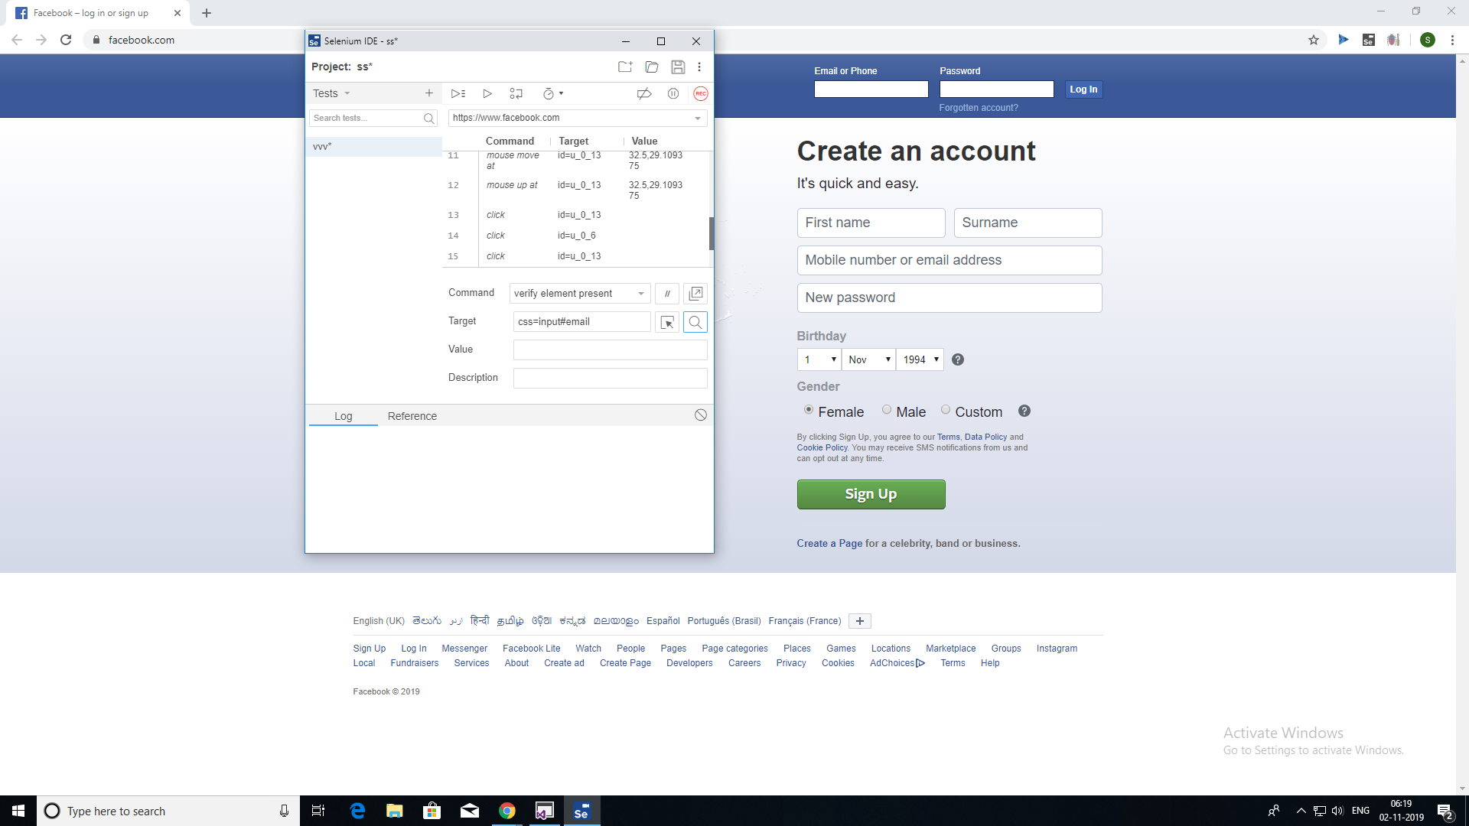

1. Now click on search button beside target field. Now, email field will blink.



**Using Tag and Class:**

1. Now inspect and copy **class** field value for Email or Phone field.



1. In command field, give **verify element present** and in target give **css=input.inputtext.**
2. (Note: **inputtext** is the class value for email field present in facebook home page which was copied before. And **input** is the tag name).

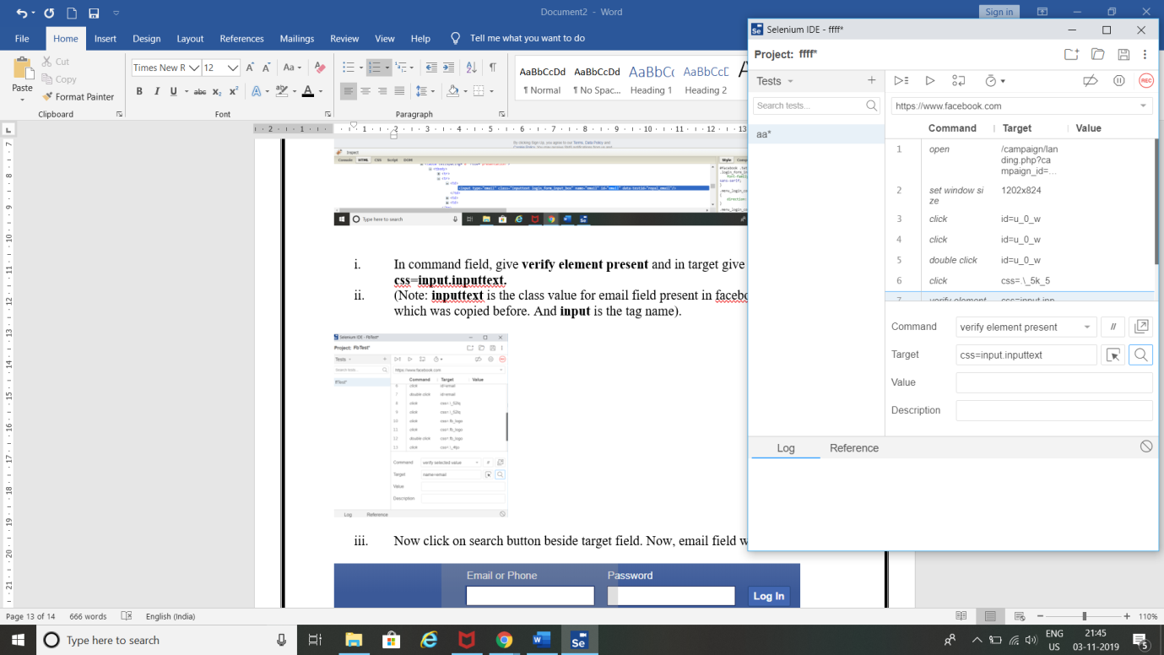

1. Now click on search button beside target field. Now, email field will blink.



**Result:**

Thus, using CSS selectors for identifying Web elements for selenium scripts using Selenium IDE has been completed.